Given that my_val is a list of float values, which of the following is an example of a built-in function?

a. my_val.capitalize()

b. my_val.title()

c. len(my_val)

d. average(my_val)

A user is interested in creating an object to create a stock inventory at a grocery store. Which of the following would be appropriate attributes of an object that they may use?

a. managers_name, no_of_days_on_shelf, employee_id, calculate_employee_age()

b. totat_employees, employee_id, aisle_number, calculate_if_expired()

c. stock_item_names, managers_name, total_employees, street_address

d. stock_item_names, expiry_dates, aisle_number, calculate_if_expired()

Which built-in object is mutable?

a. bool

b. int

c. str

d. list

Which of the following is an attribute of the class shown below?

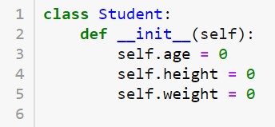

a. student

b. init

c. weight

d. def __init__(self)

Complete the code below to produce Student Name: ABC and Student Age: 10 as the output.

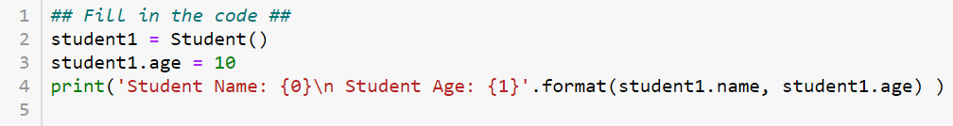

a. 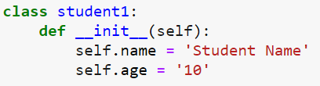

b. 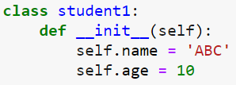

c. 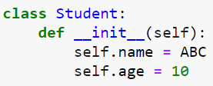

d. 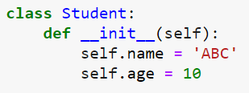

Which of the following is an instance created by the code given below?

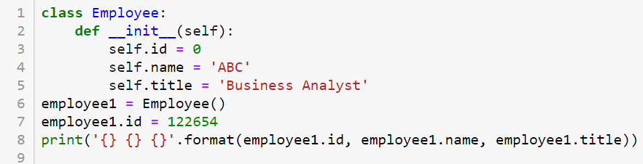

a. Employee

b. employee1

c. id

d. 122654

Given the following class definition, which of the following is the correct call for the method?

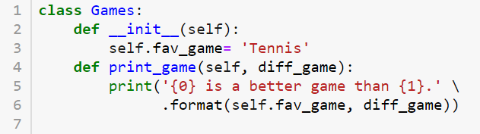

a.

my_game = Games()

my_game.print_game('Rugby')

b.

my_game = Games()

my_game.print_game()

c.

my_game = Games()

my_game.print_game(self, 'Rugby')

d.

my_game = Games()

my_game.print_game(self)

Which of the following is a correct definition for an instance method, print_age(), that has two parameters, date_of_birth and date_today, passed to it?

a. def print_age(self):

b. def print_age(self, date_of_birth, date_today):

c. def print_age(date_of_birth, date_today):

d. def print_age():

Choose the code that generates the following output: Total marks: 500 No of subjects: 6 Average Score: 83.3

a. 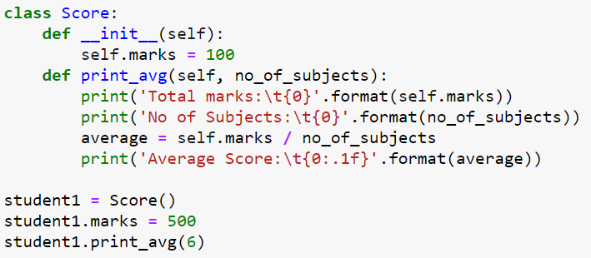

b. 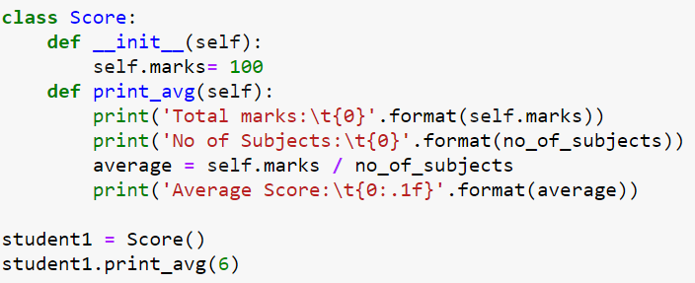

c. 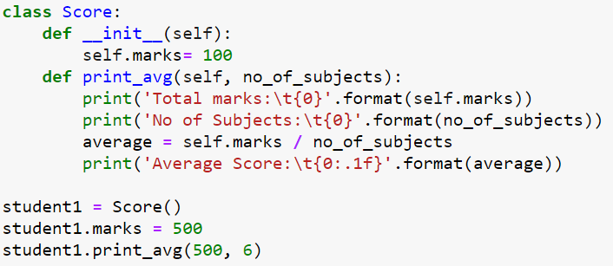

d.

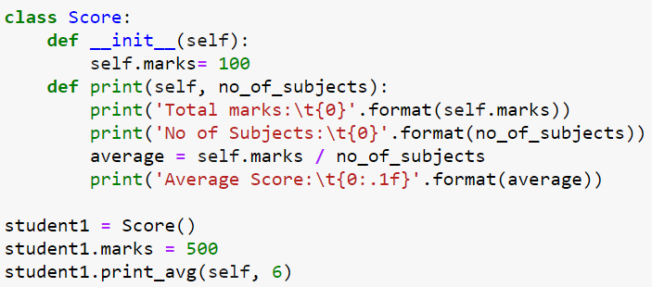

A function defined within a class is known as a(n) _________.

a. class attribute

b. method object

c. instance method

d. class object

A(n) _________ represents a single instance of a class.

a. instance object

b. instance attribute

c. class object

d. class attribute

In the below code, identify the correct instantiation of a new class object.

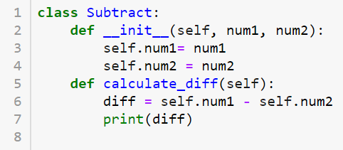

a. diff1 = Subtract()

b. diff1.calculate_diff(25, 10)

c. diff1.calculate_diff()

d. diff1 = Subtract(25, 10)

In the following constructor, identify the correct instantiation.

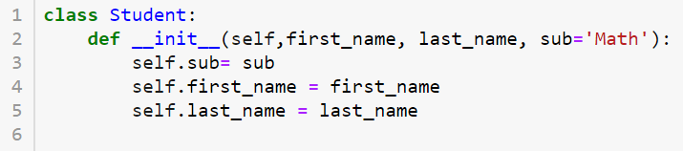

a. Student()

b. Student('Daniel', 'Smith')

c. Student('Daniel')

d. Student(sub = 'English')

Complete the code to generate 'Rita Williams attends English class' as the output.

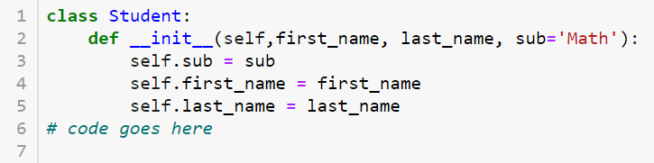

a.

student1 = Student('Rita', 'Williams', 'English')

print('{0} {1} attends {2} class'.format(student1.first_name, student1.last_name, student1.sub))

b.

student1 = Student('Rita', 'Williams')

print('{0} {1} attends {2} class'.format(student1.first_name, student1.last_name, student1.sub))

c.

student1 = Student()

print('{0} {1} attends {2} class'.format(student1.first_name, student1.last_name, student1.sub))

d.

Student('Rita', 'Williams', 'English')

print('{0} {1} attends {2} class'.format( Student.first_name, Student.last_name, Student.sub))

What is output?

new_string = 'One giant leap for mankind'

print(new_string[0:6])

a. Onegia

b. One gi

c. One gia

d. 'Onegi

Consider the string new_string = 'Code development in Python' . Which statement will return **velop** as a substring?

Answer

a. new_string[-18:12]

b. new_string[7:11]

c. new_string[8:12]

d. new_string[-19:12]

Complete the following code to get Email me at abc@gmail.com or call at 333 222 1111 as output.

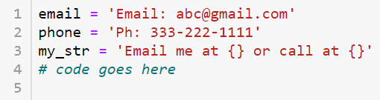

a. print(my_str.format(email.split(' '), ' '.join((phone.split(': ' )))))

b. print(my_str.format(email.split(' '), ' '.join((phone.split(': ' )[1]))))

c. print(my_str.format(email.split(' ')[0], ' '.join((phone.split(': ' )[0].split('-')))))

d. print(my_str.format(email.split(' ')[1], ' '.join((phone.split(': ' )[1]).split('-'))))

What is output?

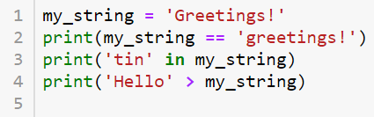

a.

False

True

True

b.

True

True

True

c.

True

True

False

d.

False

True

False

Given a list my_list = [[0, 1, 2], [3, 4, 5], [6, 7, 8]] , how would you access the value 7?

a. my_list[2][1]

b. my_list[2][2]

c. my_list[3][2]

d. my_list[3][1]

Consider the lists my_list = [['The', 'Magic'] , ['Rhonda', 'Byrne']] and new_list = [] . Select the option that will produce The Magic : Rhonda Byrne as the output.

a.

for i, j in enumerate(my_list):

new_list.append(j)

print('{} {}: {} {}'.format(new_list[0], new_list[1], new_list[2], new_list[3]))

b.

for i, j in enumerate(my_list):

new_list = j

print('{} {}: {} {}'.format(new_list[0], new_list[1], new_list[2], new_list[3]))

c.

for i, j in enumerate(my_list):

new_list = my_list[i]

print('{} {}: {} {}'.format(new_list[0], new_list[1], new_list[2], new_list[3]))

d.

for i, j in enumerate(my_list):

for item in my_list[i]:

new_list.append(item)

print('{} {}: {} {}'.format(new_list[0], new_list[1], new_list[2], new_list[3]))

What’s the output?

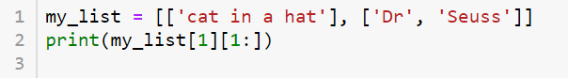

a. ['Dr']

b. ['in a hat']

c. ['Seuss']

d. ['Dr', 'Seuss']

Choose the print statement that generates ['a', 'd'] as the output for my_list = ['a', 'b', 'c', 'd', 'e', 'f', 'g'] .

a. print(my_list[0:5:2])

b. print(my_list[0:-1:3])

c. print(my_list[0:-2:2])

d. print(my_list[1:-2:2])

Which data type is the correct choice to store the number of wins associated with each basketball team in the NBA?

a. float

b. string

c. tuple

d. dict

Which statement is true regarding the pop() method for sets?

a. pop() removes the first item added to the set.

b. pop() removes the last item added to the set.

c. pop() removes a random item in the set.

d. pop() returns but does not remove a random item in the set.

Which of the following statements assigns a new variable, my_set, with a set that contains three elements?

a. my_set = set([1, 2, 3])

b. my_set = set(3)

c. my_set = [1, 2, 3].to_set()

d. my_set = { [1, 2, 3] }

Which of the following statements removes the value ‘Google’ from the set, companies?

companies = { ‘Apple’, ‘Microsoft’, ‘Google’, ‘Amazon’ }

a. companies.pop(2)

b. companies.pop(‘Google’)

c. companies.remove(2)

d. companies.remove(‘Google’)

What values are in result_set after the following code is run?

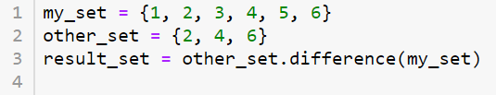

a. { }

b. {1, 3, 5}

c. {2, 4, 6}

d. {1, 2, 3, 4, 5, 6}

The variable emails_dict is assigned with a dictionary that associates student ids with email addresses. Which statement prints the email address associated with the student id "C2104"?

a. print(value of emails_dict("C2104"))

b. print(key of emails_dict("C2104"))

c. print(emails_dict["C2104"])

d. print(emails_dict["bob@someuni.edu"])

Which statement removes entry "1G1JB6EH1E4159506" from the dictionary cars_dict?

a. cars_dict["1G1JB6EH1E4159506"] = None

b. cars_dict{"1G1JB6EH1E4159506"}.del()

c. delete(cars_dict["1G1JB6EH1E4159506"])

d. del cars_dict["1G1JB6EH1E4159506"]

What is the output?

a. [5, 6, 7, 9, 10] [10, 9, 7, 6, 5]

b. [5, 6, 7, 9, 10] [5, 6, 7, 9, 10]

c. [5, 6, 7, 9, 10] [9, 7, 6, 5]

d. [5, 6, 7, 9, 10] [5, 6, 7, 9]

Which of the following options can sort the list in descending order?

i. list_name.sort(reverse=True)

ii. sorted(list_name, reverse=True)

iii. sorted(list_name)[::-1]

iV. sorted(list_name)

a. i, ii, iV

b. i, ii, iii

c. i, ii

d. i, ii, iii, iV

What will be the date type for type(list_name.sort()) and type(sorted(list_name)) ?

a. < class 'NoneType'>, < class 'NoneType'>

b. < class 'list'>, < class 'NoneType'>

c. < class 'list'>, < class 'list'>

d. < class 'NoneType'>, < class 'list'>

What is the length of the dictionary my_dict = {'Country':'India', 'State': {'City':'Delhi', 'Temperature':40}} ?

a. 4

b. 3

c. 2

d. 5

What is output?

dict = {1: "X", 2: "Y", 3: "Z"}

print(dict.get(2, "A"))

a. Z

b. A

c. Error, invalid syntax

d. Y

What is output?

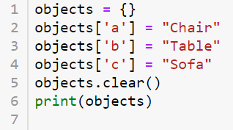

a. {"a":"Chair", "b":"Table", "c":"Sofa"}

b. {"Chair", "Table", "Sofa"}

c. {}

d. {"a", "b", "c"}

What is output?

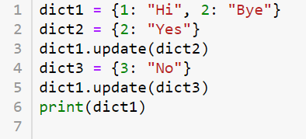

a. {1: "Hi", 2: "Bye", 2: "Yes", 3: "No"}

b. {1: "Hi", 2: "Yes", 3: "No"}

c. {1: "Hi", 2: "ByeYes", 3: "No"}

d. {1: "Hi", 2: "Yes", 2: "Bye", 3: "No"}

Identify the error in the program given below.

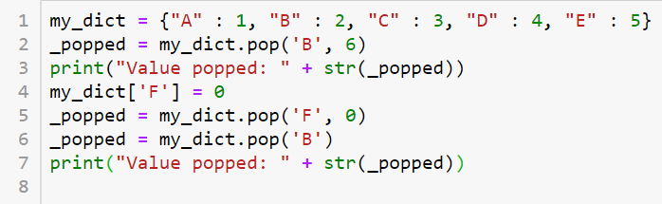

a. my_dict.pop('F', 0) causes error

b. my_dict.pop('B', 6) causes error

c. print("Value popped: " + str(_popped)) causes error

d. my_dict.pop('B') causes error

How do you obtain a list of tuples of key-value pairs in a dictionary dict ?

a. dict.get(key, default)

b. dict.values()

c. dict.items()

d. dict.keys()

Which of the following code blocks will print both keys and values?

a.

dict1 = {}

dict1['number'] = 10

dict1['color'] = 'Red'

dict1['word'] = 'Chair'

for values in dict1:

print(values)

b.

dict1 = {'number': 10, 'color': 'Red', 'word': 'Chair'}

for keys, values in dict1.items():

print(dict1[keys], values)

c.

dict1 = dict(number = 10, color = 'Red', word = 'Chair')

for keys, values in dict1.items():

print(keys, values)

d.

dict1 = {'number': 10, 'color': 'Red', 'word': 'Chair'}

for keys, values in dict1:

print(keys, dict1[keys])

What is a valid input?

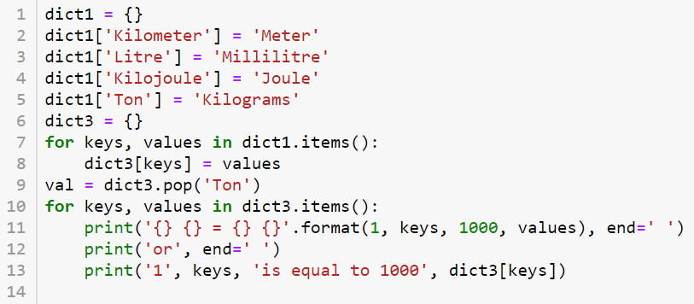

a.

1 Kilometer = 1000 Meter or 1 Kilometer is equal to 1000 Meter

1 Kilojoule = 1000 Joule or 1 Kilojoule is equal to 1000 Joule

1 Litre = 1000 Millilitre or 1 Litre is equal to 1000 Millilitre

b.

1 Kilometer = 1000 Meter or 1 Kilometer is equal to 1000 Meter

1 Kilojoule = 1000 Joule or 1 Kilojoule is equal to 1000 Joule

1 Litre = 1000 Millilitre or 1 Litre is equal to 1000 Millilitre

1 Ton = 1000 Kilograms or 1 Ton is equal to 1000 Kilograms

c.

1 Meter = 1000 Kilometer or 1 Meter is equal to 1000 Kilometer

1 Joule = 1000 Kilojoule or 1 Joule is equal to 1000 Kilojoule

1 Millilitre = 1000 Litre or 1 Millilitre is equal to 1000 Litre

d.

1 Meter = 1000 Kilometer or 1 Meter is equal to 1000 Kilometer

1 Joule = 1000 Kilojoule or 1 Joule is equal to 1000 Kilojoule

1 Millilitre = 1000 Litre or 1 Millilitre is equal to 1000 Litre

1 Kilograms = 1000 Ton or 1 Kilograms is equal to 1000 Ton

Select the line of code which is a 2-D array.

a. np.array([1,2,3,4,5])

b. np.array([1,2,3,4,5],[6,7,8,9,10])

c. np.array((1,2,3,4,5),(6,7,8,9,10))

d. np.array([(1,2,3,4,5),(6,7,8,9,10)])

Which numpy function creates the sequence [0.4,0.5,0.6,0.7]?

a. np.linspace(0.4,0.7,4)

b. np.range(0.4,0.7,4)

c. np.arange(0.4,0.7,4)

d. np.array(0.4,0.7,4)

What is the value of sys.argv[1]+len(sys.argv[1]) for the command-line input > python prog.py 121 ?

a. 1213

b. 124

c. 121

d. Runtime error

Which of the following statements returns '< class 'list'>, 5‘ as the output for the command-line input

python prog.py 1 January 2020

a. print(type(sys.argv), sys.argv[1]+len(sys.argv))

b. print(type(sys.argv[1]), sys.argv[0]+len(sys.argv))

c. print(type(sys.argv), int(sys.argv[1])+len(sys.argv))

d. print(type(sys.argv[1]), int(sys.argv[0])+len(sys.argv))

Identify the correct syntax for importing modules from the script readFile.py?

a. import readFile.py

b. import readFile

c. Import ReadFile

d. import READFILE

Which of the following directories is contained in sys.path ?

a. All available directories on your computer.

b. Directories of all local files used by the script.

c. The directory where Python is installed.

d. The root directory on your computer.

_____ can be set to specify optional directories where modules are located.

a. sys.path

b. python.path

c. SYSPATH

d. PYTHONPATH

Consider a module file named Rectangle containing functions calc_area() and length(). Which option is the right way to import only these functions?

a.

import calc_area(5, 10)

calc_area(5, 10)

b.

import Rectangle

print(calc_area(5, 10))

c.

from Rectangle import (calc_area, length)

print(calc_area(5, 10))

d.

import calc_area, length

calc_area(5, 10)

Which of the following statements imports an entire module named ABC ?

a. from ABC import All

b. from ABC import print_val

c. from ABC import as all

d. import ABC

Consider a package Shapes that contains the modules square.py, rectangle.py, and circle.py. Which of the following statements should be used to import rectangle.py?

a. import Shapes.rectangle

b. import rectangle.py

c. import Shapes.rectangle.py

d.

import Shapes

import rectangle

Which is the correct syntax for opening a file in Python?

a. my_file = readlines('Wikipedia_data.txt')

b. my_file = read('Wikipedia_data.txt')

c. my_file = open('Wikipedia_data.txt')

d. my_file = open_text('Wikipedia_data.txt')

Which of the following statements reads up to 100 bytes from a file named student.txt?

a. my_file = open('student.txt', 100)

b.

my_file = open('student.txt')

line = my_file.read(100)

c.

my_file = open('student.txt')

line = my_file[100]

d. my_file = read('student.txt', 100)

memberDetails.txt file contains the following.

Name: Ben

Age: 50

Complete the code to print Ben.

file = open('memberDetails.txt')

# code goes here

file.close()

a.

line = file.readlines(6)

print(line)

b.

line = file.readline()[6:]

print(line)

c.

line = file.readlines(1)[6:]

print(line)

d.

line = file.readline(6)

print(line)

Identify the correct syntax used to write to a text file?

a.

file = open('My_data.txt', 'w')

file.write("This file contains data")

b.

file = open('My_data.txt', 'w')

file.write(100)

c.

file = open('My_data.txt', 'w')

file.write([100, 200, 300])

d.

file = open('My_data.txt', 'a')

file.write(["hello", "hi", "hey"])

Which statement opens a file for appending?

a. file = open('ABC.txt', 'a')

b. file = open('ABC.txt', 'r')

c. file = open('ABC.txt', 'rw')

d. file = open('ABC.txt', 'w')

Complete the code to append the values in my_list to a file named my_data.txt with one value in each line.

my_list = [10, 20, 30, 50]

# code goes here

a.

file = open('my_data.txt', 'a+')

for i in my_list:

file.write(i)

b.

file = open('my_data.txt', 'w')

for i in my_list:

file.write(str(i) + '\n')

c.

file = open('my_data.txt', 'a+')

for i in my_list:

file.write(str(i) + '\n')

d.

file = open('my_data.txt', 'w+')

for i in my_list:

file.write(i)

Identify the loop that prints the names of the directories, subdirectories, and files in a path.

a.

for dirname, subdirs, files in os.path(path):

print(dirname, subdirs, files)

b.

for files in os.path(path):

print(files)

c.

for dirname in os.walk(path):

print(dirname[0], dirname[1], dirname[2])

d.

for dirname, subdirs, files in os.walk(path):

print(dirname, subdirs, files)

The letter e has a hexadecimal value of 0x65. Which of the following codes prints the bytes literal value e?

a. print(b'\x65')

b. print(b'\0x65')

c. print('b0\x65')

d. print(b'0\x65)

Which of the following statements prints the last field in each row of the csv file?

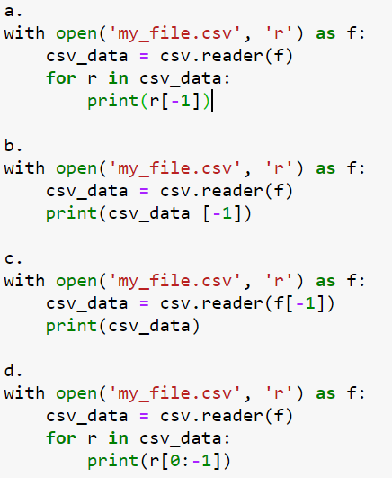

See the next page for the answer.

The answer to the previous problem is a

Which code opens a csv file with semicolon as a delimiter?

a.

with open('my_file.csv', 'r') as file:

csv_data = csv.reader('my_file.csv', delimiter = ';')

b.

with open('my_file.csv', 'r') as file:

csv_data = csv.reader(file, delimiter = ';')

c.

with open('my_file.csv', 'r') as file:

csv_data = csv.reader('file', delimiter = 'semicolon')

d.

with open('my_file.csv', 'r') as file:

csv_data = csv.reader(file)

Complete the code to plot Salary=[5,6,7,8] and Grade=[100,200,300,400].

import numpy as np

import matplotlib.pyplot as plt

# code goes here

a.

plt.plot()

plt.show(Salary,Grade)

b.

plt.plot(Salary,Grade).show()

c.

plt.plot(Salary,Grade)

plt.show()

d.

plt.show([5,6,7,8],[100,200,300,400])

plt.plot()

Which function takes an optional format string argument to specify the color and style of the plotted line?

a. plt.show()

b. plt.imshow()

c. plt.legend()

d. plt.plot()

In plt.plot(X, Y, color='ro-', linewidth=5, markersize=5, alpha=0.35) , which property is defined by alpha?

a. transparency

b. anti-aliasing

c. color contrast

d. animation

Select the format string used to style the lines as shown in the image.

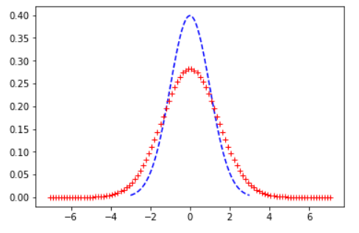

a. r+ and b-

b. r+ and b--

c. r++. and b--.

d. r+ and c-

Which code defines a red X marker of size 5 and line width 10 for a line plot?

a. plt.plot(X,Y,'r-',marker='x',linewidth=10,markersize=5)

b. plt.plot(X,Y,'r-X',line_width=10,marker_size=5)

c. plt.plot(X,Y,'rX',linewidth=10,markersize=5)

d. plt.plot(X,Y,'r',marker='X',linewidth=10,markersize=5)

Identify the correct syntax to annotate the data point at (5,2) placing the text Peak at (5,3).

a. plt.annotate('Peak',xy=(5,2),xytext=(5,3))

b. plt.annotate('Peak',xy=(5,3),xytext=(5,2))

c. plt.annotate(xy=(5,2),xytext=(5,3))

d. plt.annotate(xy=(5,3),xytext=(5,2))

Which code generates the following output?

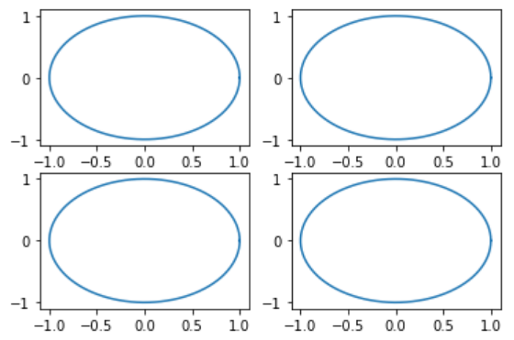

a.

theta1 = np.linspace(0, 2*np.pi, 100)

r = 1

plt.subplot(1)

plt.plot(r*np.cos(theta1), r*np.sin(theta1))

plt.subplot(2)

plt.plot(r*np.cos(theta1), r*np.sin(theta1))

plt.subplot(3)

plt.plot(r*np.cos(theta1), r*np.sin(theta1))

plt.subplot(4)

plt.plot(r*np.cos(theta1), r*np.sin(theta1))

plt.show()

b.

theta1 = np.linspace(0, 2*np.pi, 100)

r = 1

plt.subplot(2, 2, 1)

plt.plot(r*np.cos(theta1), r*np.sin(theta1))

plt.subplot(2, 2, 2)

plt.plot(r*np.cos(theta1), r*np.sin(theta1))

plt.subplot(2, 2, 3)

plt.plot(r*np.cos(theta1), r*np.sin(theta1))

plt.subplot(2, 2, 4)

plt.plot(r*np.cos(theta1), r*np.sin(theta1))

plt.show()

c.

theta1 = np.linspace(0, np.pi, 100)

r = 1

plt.subplot(2, 2, 1)

plt.plot(r*np.cos(theta1), r*np.sin(theta1))

plt.subplot(2, 2, 2)

plt.plot(r*np.cos(theta1), r*np.sin(theta1))

plt.subplot(2, 2, 3)

plt.plot(r*np.cos(theta1), r*np.sin(theta1))

plt.subplot(2, 2, 4)

plt.plot(r*np.cos(theta1), r*np.sin(theta1))

plt.show()

d.

theta1 = np.linspace(0, 2*np.pi, 100)

r = 1

plt.subplot(4, 1)

plt.plot(r*np.cos(theta1), r*np.sin(theta1))

plt.subplot(4, 2)

plt.plot(r*np.cos(theta1), r*np.sin(theta1))

plt.subplot(4, 3)

plt.plot(r*np.cos(theta1), r*np.sin(theta1))

plt.subplot(4, 4)

plt.plot(r*np.cos(theta1), r*np.sin(theta1))

plt.show()

The next few problems will use the following data frame

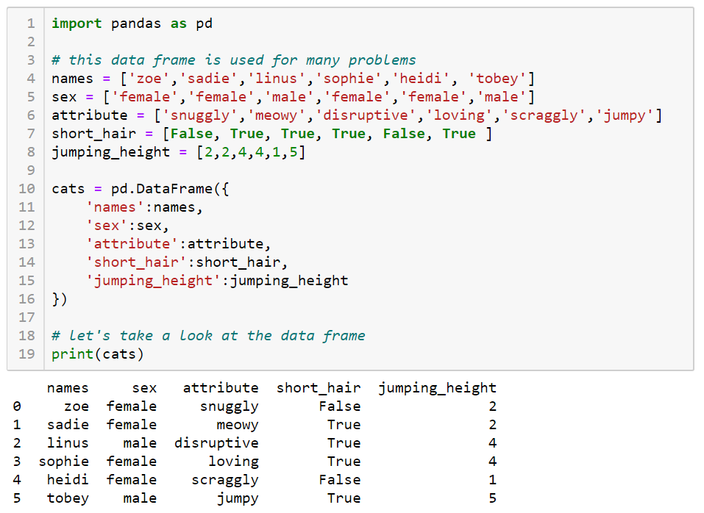

Write functions that:

* correctly computes and returns the average jumping height for cats
* correctly computes and returns the average jumping height for male cats
* correctly computes and returns the two largest jumping heights for cats
* correctly computes and returns the number of times the mode of the sex column appears

